 | 7.3.12 Editors - 3D Viewport - Sidebar - Tool Tab - Grease Pencil - Draw Mode
Table of content
Detailed table of content 1
Draw Mode 7
Brush Asset Panel 7
Brush Settings Panel 9
Brush Settings Panel - Draw brushes 10
Brush Settings Panel - Draw brushes - Advanced Sub panel 13
Brush Settings Panel - Draw brushes - Stroke Sub panel 14
Brush Settings Panel - Erase 24
Brush Settings Panel - Fill 27
Brush Settings Panel - Fill - Advanced Sub panel 27
Color Panel 29
Color Panel - Palette sub panel 30

Detailed table of content
Detailed table of content
Detailed table of content 1
Draw Mode 7
Brush Asset Panel 7
Browse Brush 7
Brush Specials menu 8
Edit Metadata 8
Catalog 8
Author 8
Desctription 8
OK / Cancel 8
Edit Preview Image 8
Save Brush Asset 8
Revert Brush Asset 8
Name 8
Brush Settings Panel 9
Header - Add Brush Preset 9
Material Browser 9
Drop down box 10
Brush Settings Panel - Draw brushes 10
Size 10
Use Pressure 10
Pressure Size Curve 10
Selecting Points 10
Adding Points 11
Navigation elements 11
Zoom in 11
Zoom out 11
Clipping options 11
Tools 11
Reset View 11
Reset Curve 11
Handles 11
Position X / Y 11
Delete Points 11
Curve Presets 11
Strength 11
Use Pressure 11
Pressure Size Curve 12
Selecting Points 12
Adding Points 12
Navigation elements 12
Zoom in 12
Zoom out 12
Clipping options 12
Tools 12
Reset View 12
Reset Curve 12
Handles 12
Position X / Y 13
Delete Points 13
Curve Presets 13
Caps Type 13
Brush Settings Panel - Draw brushes - Advanced Sub panel 13
Radius Unit 13
Spacing 13
Active Smooth 13
Angle 13
Factor 13
Hardness 13
Aspect 14
Brush Settings Panel - Draw brushes - Stroke Sub panel 14
Post Processing 14
Smooth 14
Iterations 14
Iterations 14
Subdivision Steps 14
Simplify 14
Trim Stroke Ends 14
Outline 14
Material 15
Thickness 15
Randomize 15
Radius 15
Stroke Randomization 15
Use Pressure 15
Pressure Size Curve 15
Selecting Points 15
Adding Points 15
Navigation elements 16
Zoom in 16
Zoom out 16
Clipping options 16
Tools 16
Reset View 16
Reset Curve 16
Handles 16
Position X / Y 16
Delete Points 16
Curve Presets 16
Strength 16
Stroke Randomization 16
Use Pressure 16
Pressure Size Curve 16
Selecting Points 17
Adding Points 17
Navigation elements 17
Zoom in 17
Zoom out 17
Clipping options 17
Tools 17
Reset View 17
Reset Curve 17
Handles 17
Position X / Y 17
Delete Points 17
Curve Presets 18
Rotation 18
Stroke Randomization 18
Use Pressure 18
Pressure Size Curve 18
Selecting Points 18
Adding Points 18
Navigation elements 18
Zoom in 18
Zoom out 18
Clipping options 19
Tools 19
Reset View 19
Reset Curve 19
Handles 19
Position X / Y 19
Delete Points 19
Curve Presets 19
Hue 19
Stroke Randomization 19
Use Pressure 19
Saturation 19
Stroke Randomization 19
Use Pressure 20
Pressure Size Curve 20
Selecting Points 20
Adding Points 20
Navigation elements 20
Zoom in 20
Zoom out 20
Clipping options 20
Tools 20
Reset View 20
Reset Curve 20
Handles 21
Position X / Y 21
Delete Points 21
Curve Presets 21
Value Jitter 21
Stroke Randomization 21
Use Pressure 21
Pressure Size Curve 21
Selecting Points 21
Adding Points 21
Navigation elements 22
Zoom in 22
Zoom out 22
Clipping options 22
Tools 22
Reset View 22
Reset Curve 22
Handles 22
Position X / Y 22
Delete Points 22
Curve Presets 22
Jitter 22
Use Pressure 22
Pressure Size Curve 22
Selecting Points 23
Adding Points 23
Navigation elements 23
Zoom in 23
Zoom out 23
Clipping options 23
Tools 23
Reset View 23
Reset Curve 23
Handles 23
Position X / Y 23
Delete Points 23
Curve Presets 23
Stabilize Stroke subpanel 24
Radius 24
Factor 24
Brush Settings Panel - Erase 24
Size 24
Use Pressure 24
Pressure Size Curve 24
Selecting Points 24
Adding Points 24
Navigation elements 25
Zoom in 25
Zoom out 25
Clipping options 25
Tools 25
Reset View 25
Reset Curve 25
Handles 25
Position X / Y 25
Delete Points 25
Curve Presets 25
Strength 25
Use Pressure 25
Pressure Size Curve 25
Selecting Points 26
Adding Points 26
Navigation elements 26
Zoom in 26
Zoom out 26
Clipping options 26
Tools 26
Reset View 26
Reset Curve 26
Handles 26
Position X / Y 26
Delete Points 26
Curve Presets 27
Keep Caps 27
Active Layer 27
Brush Settings Panel - Fill 27
Direction 27
Precision 27
Leak Size 27
Thickness 27
Brush Settings Panel - Fill - Advanced Sub panel 27
Boundary 28
Layers 28
Simplify 28
Ignore Transparency 28
Limit to Viewport 28
Auto-Remove Fill Guides 28
Gap closure sub panel 28
Size 28
Mode 28
Extend 28
Radius 28
Visual Aids 29
Stroke Collision 29
Color Panel 29
Material / Vertex Color 29
Color picker 29
Active color 29
Brush colors flip 29
Mode 29
Mix Factor 29
Color Panel - Palette sub panel 30
Palette browser 30
Edit Box 30
Number of users 30
Fake User 30
Add palette 30
Remove Palette 30
New Palette color 30
Delete Palette color 30
Move Palette Color up and down 31
Sort By 31
Palette Colors 31

Draw Mode

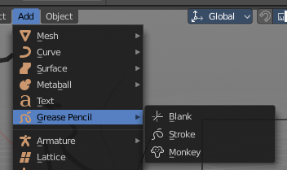
Just the grease Pencil object has a Draw mode.
The Grease Pencil Object allows you to draw in 2D in the workspace.
It starts as an object type. By switching into paint mode it becomes a paint feature. And editing turns it into a curve or a mesh object then.
In the Tools tab you will find all the options and settings for drawing and manipulating the grease pencil object, means your drawing.
The type Blank allows you to draw strokes.
The type Stroke allows you to draw filled forms.
The type Monkey is just an example object.

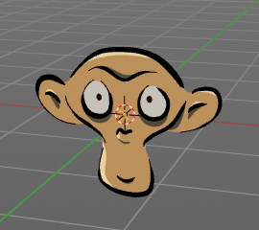
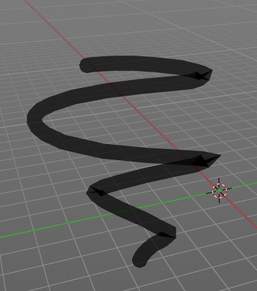
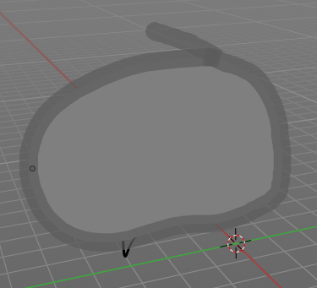

Brush Asset Panel
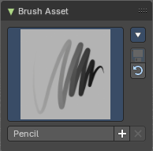
The Brush Asset Panel contains the different Brushes and some Brush settings. Choose and adjust your current active brush.

Browse Brush
The big image at the top is a dropdown box that allows you to choose a brush. Click at it, and you will see the different brushes. A click at one of the images will choose this brush then.
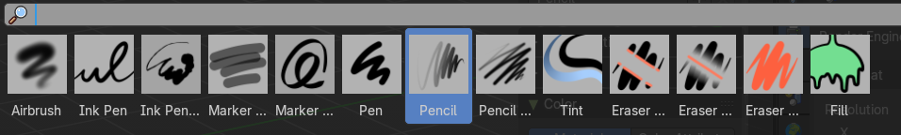
Brushes are assets. You can load them from different libraries if you want.

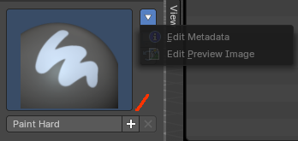
Brush Specials menu
This menu becomes active when you create a new brush. Which can be done wiht the Plus button in the name property. This data cannot be changed for builtin system brushes.

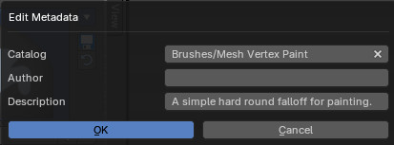
Edit Metadata
Calls a popup where you can adjust further informations and settings for the brush.

Catalog
The asset catalog in which the brush is stored.

Author
The brush author.

Desctription
Add a description

OK / Cancel
Accept or decline the changes.

Edit Preview Image
Allows you to load a custom preview image.

Save Brush Asset
This button is just active with a custom brush. It saves all changes made at the brush settings into the current custom brush.

Revert Brush Asset
Reverts the brush settings to the default values of the brush in the asset library.

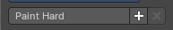
Name
The edit box below the Image shows the name of the current active brush.
The + button allows you to add a new pencil with the current settings. Note that the brushes are NOT automatically saved when you close Bforartists. You need to save the brush asset. See above.
The X button deletes the brush from the brushes list and from the asset library. This button is just active with a custom brush. You will be prompted by a warning so that you don't accidentally remove the brush.

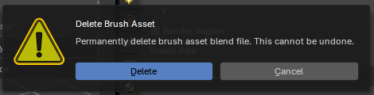

Brush Settings Panel
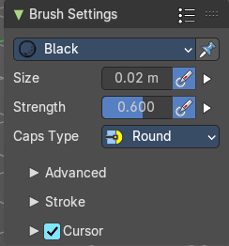

Header - Add Brush Preset
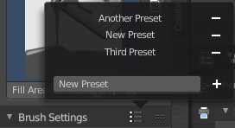
In the header is a brush preset menu where you can store and load custom brush presets. The dialog should be self explaining. In the edit box you type in the name of your new preset. And with clicking at the + button the new preset gets stored. Existing presets can be removed by clicking at the - button at the right side of the preset.

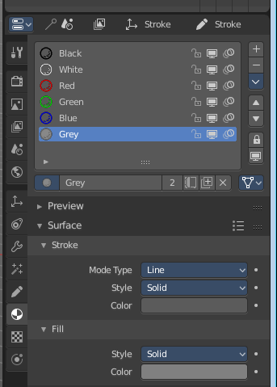
Material Browser
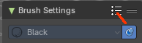
This browser is just active when the Keep material assigned to Brush Pin is activated.
The colors for the grease pencil are materials each. For the grease pencil type Blank you will just have one color available. For this type you have to create new materials in the material tab first when you need more colors. But the other two types, strokes and monkey, comes with a few base materials already. Which can be found in the Materials tab.
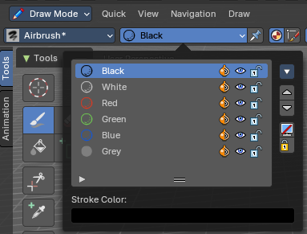
The tool settings above the header shows this panel too. And here you can quickly change the color of a material. It is explained in the chapter Materials Tab.

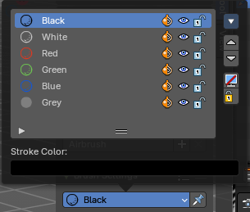
Drop down box
Choose another material to draw with.

Brush Settings Panel - Draw brushes

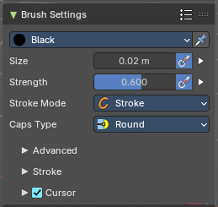
Airbrush, Ink Pen, Ink Pen Rough, Marker Bold, Marker Chisel, Pen, Pencil, Pencil Soft and Tint.
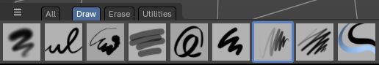

Note that not all draw brushes have curve settings for radius and strength.

Size
The size edit box allows you to adjust the size of the brush.

Use unified size
The size is shared across the brushes.

Use Pressure
The button behind the edit box enables tablet pressure sensitivity for radius.

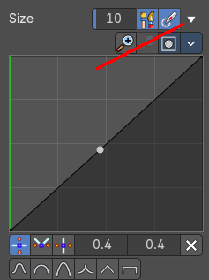
Pressure Size Curve
Behind the pressure size button there is a button to reveal the size pressure curve panel. When you activate Size Pressure for tablets, then the Size Pressure curve becomes active, and can be adjusted.
The pressure size curve allows you to adjust the falloff curve for the tablet pressure. It shows when Use Pressure is activated. The curve panel shows when clicking at the button.


Selecting Points
You can select curve points. This reveals two edit boxes for the x and y coordinate of this point.
Selected points can be moved around. Left click at them, hold the mouse button down and move them to a new location.


Adding Points
You can add new curve points by simply left clicking at the curve. Move the mouse to position them where you need it.

Navigation elements

Zoom in
Zooms in.

Zoom out
Zooms out.

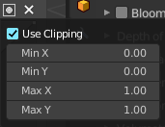
Clipping options
Set up clipping for the stroke.

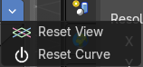
Tools
Tools is a menu where you can find some curve related tools.

Reset View
Resets the curve windows zoom.

Reset Curve
Resets the curve to the initial shape.

Handles
You can choose between Auto handle, Vector Handle and Auto Clamped.

Position X / Y
The position of the selectedc curve point.

Delete Points
Deletes the selected curve point.

Curve Presets
A curve preset to start with.

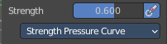
Strength
The Strength edit box allows you to adjust the strength of the brush.

Use unified size
The size is shared across the brushes.

Use Pressure
The button behind the edit box enables tablet pressure sensitivity for strength.

Pressure Size Curve
Behind the pressure size button there is a button to reveal the size pressure curve panel. When you activate Size Pressure for tablets, then the Size Pressure curve becomes active, and can be adjusted.
The pressure size curve allows you to adjust the falloff curve for the tablet pressure. It shows when Use Pressure is activated. The curve panel shows when clicking at the button.

Selecting Points
You can select curve points. This reveals two edit boxes for the x and y coordinate of this point.
Selected points can be moved around. Left click at them, hold the mouse button down and move them to a new location.

Adding Points
You can add new curve points by simply left clicking at the curve. Move the mouse to position them where you need it.

Navigation elements

Zoom in
Zooms in.

Zoom out
Zooms out.

Clipping options
Set up clipping for the stroke.

Tools
Tools is a menu where you can find some curve related tools.

Reset View
Resets the curve windows zoom.

Reset Curve
Resets the curve to the initial shape.

Handles
You can choose between Auto handle, Vector Handle and Auto Clamped.

Position X / Y
The position of the selectedc curve point.

Delete Points
Deletes the selected curve point.

Curve Presets
A curve preset to start with.

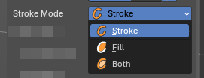
Stroke Method
Controls how Grease Pencil strokes are treated during editing and rendering. Useful for defining whether strokes act as outlines, fills, or both, depending on the drawing workflow

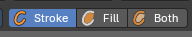
Stroke1
Points are interpreted as line strokes only. Produces visible outlines without fill regions. Best for sketching, inking, or line-based animation.

Fill
Points are interpreted as fill regions only. Creates solid shapes without visible outlines. Useful for coloring, shading, or shape-based animation.

Both
Points contribute to both stroke outlines and fill regions. Produces combined line + fill geometry. Ideal for workflows where outlines and fills need to remain linked.

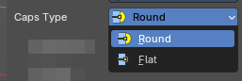
Caps Type
Controls the shape of stroke endpoints (caps). Useful for defining whether strokes end with rounded tips or flat edges, affecting both aesthetics and readability in drawings.

Round
Ends strokes with a smooth, circular cap. Creates softer, organic-looking stroke endings. Ideal for calligraphy, sketching, or expressive linework.

Flat
Ends strokes with a straight, cut-off edge. Produces sharp, mechanical-looking stroke endings. Useful for technical drawings, graphic styles, or when clean edges are required.

Brush Settings Panel - Draw brushes - Advanced Sub panel

Airbrush, Ink Pen, Ink Pen Rough, Marker Bold, Marker Chisel, Pen, Pencil, Pencil Soft and Tint.

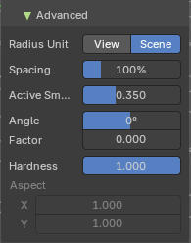
Radius Unit
Measure the brush size relative to view or scene.

Spacing
Spacing between brush daubs. Calculated as a percentage of brush diameter.

Active Smooth
The amount of smoothing while drawing.

Angle
Direction of the stroke at which the brush gives the maximal thickness. 0 degree for horoizontal.

Factor
Reduction of the brush thickness when stroke is perpendicular to the angle direction. Calculated by a factor.

Hardness
The hardness falloff from the center of dot and box strokes. 1 means a solid stroke.

Aspect
Read only. And unfortunately also not to modify. The width and height of the alpha gradient, means the brush shape.

Brush Settings Panel - Draw brushes - Stroke Sub panel

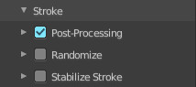
Airbrush, Ink Pen, Ink Pen Rough, Marker Bold, Marker Chisel, Pen, Pencil, Pencil Soft and Tint.

Here you will find some further stroke related settings. It has three sub sections. Post Processing, Randomize and Stabilize Stroke.

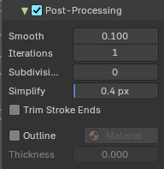
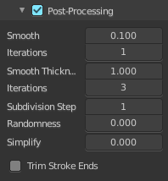
Post Processing
Here you find some post processing settings for new strokes.

Smooth
The smooth amount to reduce jittering.

Iterations
Number of iterations to smooth new created strokes.

Iterations
Number of iterations to smooth new created strokes.

Subdivision Steps
Number of subdivisions of new created strokes

Simplify
Simplify new created strokes.

Trim Stroke Ends
Trim intersecting stroke ends.

Outline
Convert stroke to perimeter. This tool requires an active camera in the scene.

Material
Material used for the secondary uses for this brush.

Thickness
The thickness of the outline stroke, relative to the current brush thickness.

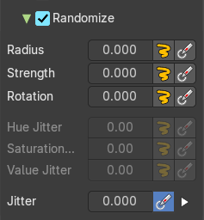
Randomize
Adds variation to the brush color per stroke or while drawing a stroke.

Radius
Randomize the pressure.

Stroke Randomization
Use randomness per stroke, instead of while drawing a stroke. This will define a new random value when you draw a new stroke.

Use Pressure
Uses the brush pressure to define how random the influence will be. Maximum pressure is maximum randomization.

Pressure Size Curve
Behind the pressure size button there is a button to reveal the size pressure curve panel. When you activate Size Pressure for tablets, then the Size Pressure curve becomes active, and can be adjusted.
The pressure size curve allows you to adjust the falloff curve for the tablet pressure. It shows when Use Pressure is activated. The curve panel shows when clicking at the button.

Selecting Points
You can select curve points. This reveals two edit boxes for the x and y coordinate of this point.
Selected points can be moved around. Left click at them, hold the mouse button down and move them to a new location.

Adding Points
You can add new curve points by simply left clicking at the curve. Move the mouse to position them where you need it.

Navigation elements

Zoom in
Zooms in.

Zoom out
Zooms out.

Clipping options
Set up clipping for the stroke.

Tools
Tools is a menu where you can find some curve related tools.

Reset View
Resets the curve windows zoom.

Reset Curve
Resets the curve to the initial shape.

Handles
You can choose between Auto handle, Vector Handle and Auto Clamped.

Position X / Y
The position of the selectedc curve point.

Delete Points
Deletes the selected curve point.

Curve Presets
A curve preset to start with.

Strength
Randomize the strength.

Stroke Randomization
Use randomness per stroke, instead of while drawing a stroke. This will define a new random value when you draw a new stroke.

Use Pressure
Uses the brush pressure to define how random the influence will be. Maximum pressure is maximum randomization.

Pressure Size Curve
Behind the pressure size button there is a button to reveal the size pressure curve panel. When you activate Size Pressure for tablets, then the Size Pressure curve becomes active, and can be adjusted.
The pressure size curve allows you to adjust the falloff curve for the tablet pressure. It shows when Use Pressure is activated. The curve panel shows when clicking at the button.

Selecting Points
You can select curve points. This reveals two edit boxes for the x and y coordinate of this point.
Selected points can be moved around. Left click at them, hold the mouse button down and move them to a new location.

Adding Points
You can add new curve points by simply left clicking at the curve. Move the mouse to position them where you need it.

Navigation elements

Zoom in
Zooms in.

Zoom out
Zooms out.

Clipping options
Set up clipping for the stroke.

Tools
Tools is a menu where you can find some curve related tools.

Reset View
Resets the curve windows zoom.

Reset Curve
Resets the curve to the initial shape.

Handles
You can choose between Auto handle, Vector Handle and Auto Clamped.

Position X / Y
The position of the selectedc curve point.

Delete Points
Deletes the selected curve point.

Curve Presets
A curve preset to start with.

Rotation
Randomize the rotation.

Stroke Randomization
Use randomness per stroke, instead of while drawing a stroke. This will define a new random value when you draw a new stroke.

Use Pressure
Uses the brush pressure to define how random the influence will be. Maximum pressure is maximum randomization.

Pressure Size Curve
Behind the pressure size button there is a button to reveal the size pressure curve panel. When you activate Size Pressure for tablets, then the Size Pressure curve becomes active, and can be adjusted.
The pressure size curve allows you to adjust the falloff curve for the tablet pressure. It shows when Use Pressure is activated. The curve panel shows when clicking at the button.

Selecting Points
You can select curve points. This reveals two edit boxes for the x and y coordinate of this point.
Selected points can be moved around. Left click at them, hold the mouse button down and move them to a new location.

Adding Points
You can add new curve points by simply left clicking at the curve. Move the mouse to position them where you need it.

Navigation elements

Zoom in
Zooms in.

Zoom out
Zooms out.

Clipping options
Set up clipping for the stroke.

Tools
Tools is a menu where you can find some curve related tools.

Reset View
Resets the curve windows zoom.

Reset Curve
Resets the curve to the initial shape.

Handles
You can choose between Auto handle, Vector Handle and Auto Clamped.

Position X / Y
The position of the selectedc curve point.

Delete Points
Deletes the selected curve point.

Curve Presets
A curve preset to start with.

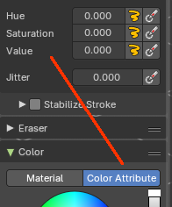
Hue
Shifts the base color across the color wheel. You need to be in color attribute mode.

Stroke Randomization
Use randomness per stroke, instead of while drawing a stroke. This will define a new random value when you draw a new stroke.

Use Pressure
Uses the brush pressure to define how random the influence will be. Maximum pressure is maximum randomization.

Saturation
Randomize original saturation. Adjusts the intensity of the color. You need to be in color attribute mode.

Stroke Randomization
Use randomness per stroke, instead of while drawing a stroke. This will define a new random value when you draw a new stroke.

Use Pressure
Uses the brush pressure to define how random the influence will be. Maximum pressure is maximum randomization.

Pressure Size Curve
Behind the pressure size button there is a button to reveal the size pressure curve panel. When you activate Size Pressure for tablets, then the Size Pressure curve becomes active, and can be adjusted.
The pressure size curve allows you to adjust the falloff curve for the tablet pressure. It shows when Use Pressure is activated. The curve panel shows when clicking at the button.

Selecting Points
You can select curve points. This reveals two edit boxes for the x and y coordinate of this point.
Selected points can be moved around. Left click at them, hold the mouse button down and move them to a new location.

Adding Points
You can add new curve points by simply left clicking at the curve. Move the mouse to position them where you need it.

Navigation elements

Zoom in
Zooms in.

Zoom out
Zooms out.

Clipping options
Set up clipping for the stroke.

Tools
Tools is a menu where you can find some curve related tools.

Reset View
Resets the curve windows zoom.

Reset Curve
Resets the curve to the initial shape.

Handles
You can choose between Auto handle, Vector Handle and Auto Clamped.

Position X / Y
The position of the selectedc curve point.

Delete Points
Deletes the selected curve point.

Curve Presets
A curve preset to start with.

Value Jitter
Randomize original value. Modifies the brightness of the stroke. You need to be in color attribute mode.

Stroke Randomization
Use randomness per stroke, instead of while drawing a stroke. This will define a new random value when you draw a new stroke.

Use Pressure
Uses the brush pressure to define how random the influence will be. Maximum pressure is maximum randomization.

Pressure Size Curve
Behind the pressure size button there is a button to reveal the size pressure curve panel. When you activate Size Pressure for tablets, then the Size Pressure curve becomes active, and can be adjusted.
The pressure size curve allows you to adjust the falloff curve for the tablet pressure. It shows when Use Pressure is activated. The curve panel shows when clicking at the button.

Selecting Points
You can select curve points. This reveals two edit boxes for the x and y coordinate of this point.
Selected points can be moved around. Left click at them, hold the mouse button down and move them to a new location.

Adding Points
You can add new curve points by simply left clicking at the curve. Move the mouse to position them where you need it.

Navigation elements

Zoom in
Zooms in.

Zoom out
Zooms out.

Clipping options
Set up clipping for the stroke.

Tools
Tools is a menu where you can find some curve related tools.

Reset View
Resets the curve windows zoom.

Reset Curve
Resets the curve to the initial shape.

Handles
You can choose between Auto handle, Vector Handle and Auto Clamped.

Position X / Y
The position of the selectedc curve point.

Delete Points
Deletes the selected curve point.

Curve Presets
A curve preset to start with.

Jitter
Add Jitter.

Use Pressure
The button behind the edit box enables tablet pressure sensitivity.

Pressure Size Curve
Behind the pressure size button there is a button to reveal the size pressure curve panel. When you activate Size Pressure for tablets, then the Size Pressure curve becomes active, and can be adjusted.
The pressure size curve allows you to adjust the falloff curve for the tablet pressure. It shows when Use Pressure is activated. The curve panel shows when clicking at the button.

Selecting Points
You can select curve points. This reveals two edit boxes for the x and y coordinate of this point.
Selected points can be moved around. Left click at them, hold the mouse button down and move them to a new location.

Adding Points
You can add new curve points by simply left clicking at the curve. Move the mouse to position them where you need it.

Navigation elements

Zoom in
Zooms in.

Zoom out
Zooms out.

Clipping options
Set up clipping for the stroke.

Tools
Tools is a menu where you can find some curve related tools.

Reset View
Resets the curve windows zoom.

Reset Curve
Resets the curve to the initial shape.

Handles
You can choose between Auto handle, Vector Handle and Auto Clamped.

Position X / Y
The position of the selectedc curve point.

Delete Points
Deletes the selected curve point.

Curve Presets
A curve preset to start with.

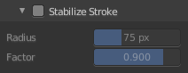
Stabilize Stroke subpanel
Draw lines with a delay to allow smooth strokes.

Radius
The minimum distance from last point before the stroke continues.

Factor
Smooth stroke factor. Higher values gives smoother stroke.

Brush Settings Panel - Erase

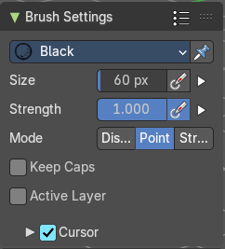
Eraser hard, Eraser Point, Eraser Soft, Eraser Stroke
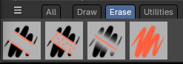

Size
The Radius edit box allows you to adjust the radius of the brush.

Use Pressure
The button behind the edit box enables tablet pressure sensitivity for radius.

Pressure Size Curve
Behind the pressure size button there is a button to reveal the size pressure curve panel. When you activate Size Pressure for tablets, then the Size Pressure curve becomes active, and can be adjusted.
The pressure size curve allows you to adjust the falloff curve for the tablet pressure. It shows when Use Pressure is activated. The curve panel shows when clicking at the button.

Selecting Points
You can select curve points. This reveals two edit boxes for the x and y coordinate of this point.
Selected points can be moved around. Left click at them, hold the mouse button down and move them to a new location.

Adding Points
You can add new curve points by simply left clicking at the curve. Move the mouse to position them where you need it.

Navigation elements

Zoom in
Zooms in.

Zoom out
Zooms out.

Clipping options
Set up clipping for the stroke.

Tools
Tools is a menu where you can find some curve related tools.

Reset View
Resets the curve windows zoom.

Reset Curve
Resets the curve to the initial shape.

Handles
You can choose between Auto handle, Vector Handle and Auto Clamped.

Position X / Y
The position of the selectedc curve point.

Delete Points
Deletes the selected curve point.

Curve Presets
A curve preset to start with.

Strength
The Strength edit box allows you to adjust the strength of the brush.

Use Pressure
The button behind the edit box enables tablet pressure sensitivity for strength.

Pressure Size Curve
Behind the pressure size button there is a button to reveal the size pressure curve panel. When you activate Size Pressure for tablets, then the Size Pressure curve becomes active, and can be adjusted.
The pressure size curve allows you to adjust the falloff curve for the tablet pressure. It shows when Use Pressure is activated. The curve panel shows when clicking at the button.

Selecting Points
You can select curve points. This reveals two edit boxes for the x and y coordinate of this point.
Selected points can be moved around. Left click at them, hold the mouse button down and move them to a new location.

Adding Points
You can add new curve points by simply left clicking at the curve. Move the mouse to position them where you need it.

Navigation elements

Zoom in
Zooms in.

Zoom out
Zooms out.

Clipping options
Set up clipping for the stroke.

Tools
Tools is a menu where you can find some curve related tools.

Reset View
Resets the curve windows zoom.

Reset Curve
Resets the curve to the initial shape.

Handles
You can choose between Auto handle, Vector Handle and Auto Clamped.

Position X / Y
The position of the selectedc curve point.

Delete Points
Deletes the selected curve point.

Curve Presets
A curve preset to start with.

Keep Caps
Keep the caps as they are. Do not flatten them.

Active Layer
Only edit the active layer of the object.

Brush Settings Panel - Fill

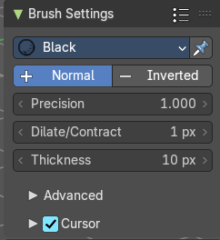
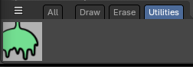

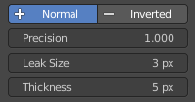
Note that the Fill tool does not fill an existing stroke like you would expect. It extends existing strokes with closed areas, or the border.

Direction
The fill direction. Fill Normal or Inverted.

Precision
Factor for fill boundary accuracy. Higher values are more accurate but slower.

Leak Size
Size in pixels to consider the leak closed.

Thickness
The thickness of the new created stroke drawn with the fill tool around existing strokes or the border.

Brush Settings Panel - Fill - Advanced Sub panel
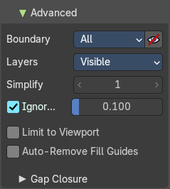

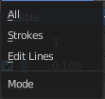
Boundary
The mode to draw the boundary lines.

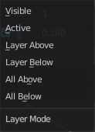
Layers
What layers to use as boundaries.

Simplify
Number of simplify steps. Large values reduces Fill accuracy.

Ignore Transparency
Show transparent lines to use as boundary for filling.

Limit to Viewport
Threshold to consider a color as transparent for filling.

Auto-Remove Fill Guides
Automatically remove fill guide strokes after filling.

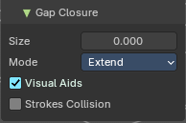
Gap closure sub panel

Size
Strokes end extension for closing gaps. A value of zero disables the feature.

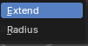
Mode

Extend
Extend strokes in straight lines.

Radius
Connect endpoints that are close together.

Visual Aids
Show help lines for stroke extension.

Stroke Collision
Check if extend lines collides with the strokes.

Color Panel
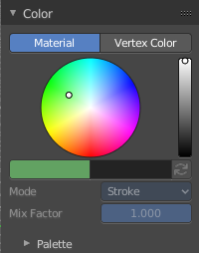
The default grease pencil color is based at materials. And then this panel is greyed out and dysfunctional. But you can also choose to work with vertex colors instead. And then all the color panel features becomes activated.

Material / Vertex Color
Choose if you want to work with material based colors or with vertex colors. Turn it to vertex colors to activate the features.
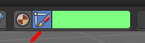
This can also be done in the tool settings in the header.

Color picker
Define the color for your brush.

Active color
The active color is the left one. When you click the button with the two arrows down right then you can swap the color with the secondary color. Then this secondary color becomes the primary color, and is active.
A click at one of the color fields will open a more detailed color dialog, to Set up the color by using rgb, hsv and hex colors and with value sliders.

Brush colors flip
Flips the primary color with the secondary color.

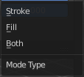
Mode
How the vertex color is applied.

Mix Factor
Factor used to mix the vertex color to get final color.

Color Panel - Palette sub panel

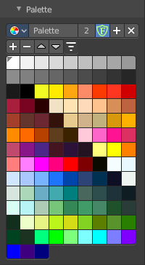
Here you will find a predefined color palette, and here you can create a color palette for later reuse.
The color palette cannot be saved externally. It is part of the current blend file. You can however append color palettes from other blend files.
The currently active color is the one with the triangle at it.

The elements are explained from left to right and from top to bottom.

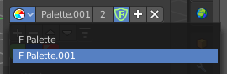
Palette browser
The button at the left opens a drop down list to choose between your palettes.

Edit Box
Read the name of the currently active palette. You can also rename the palette here. A click into the edit box makes the name editable.

Number of users
See how many users the palette currently has.

Fake User
Fake User sets the element to have a fake user. Zero user data-blocks are normally not saved. But sometimes you want to force the data to be kept even when the data block has no user.

Add palette
Add a new palette.

Remove Palette
Clicking at this button removes the palette. Note that you need to save, close Bforartists and reload the blend file to remove the palette completely.

New Palette color
Adjust a color in the color picker. Then click at the add button to add this color to the palette.

Delete Palette color
Select the color in the palette, then click at the minus button to remove it.

Move Palette Color up and down
With these two buttons you can move the active color up or down in the palette.

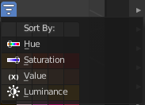
Sort By
Sort the palette by different methods.

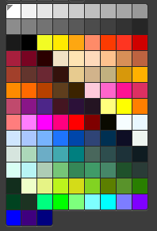
Palette Colors
The actual list of the current palette colors. Click at one to make it the active one that gets used for painting.

